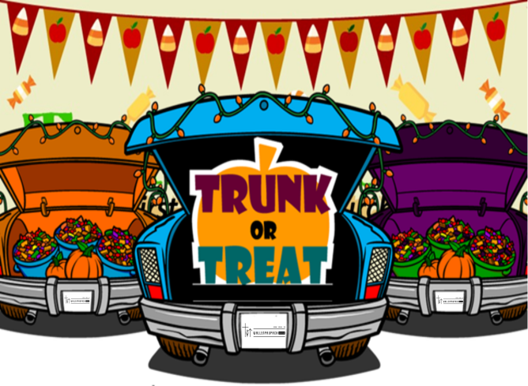
WALLENPAUPACK CHURCH
Trunk or Treat
At Wallenpaupack High School

Sunday, October 23, 2022
2pm-4pm

Guidelines for Trunk or Treat Vehicles

- Be as creative as you’d like - keeping in mind that decorations should be geared toward young children. No blood, devils, skeletons, gory, scary, or creepy creatures. (If you do not comply you will be asked to take them down. If you are unsure what’s appropriate email questions directly to Pastor Mike De Vito.)
- Remember parents have chosen to come to our event expecting it to be a safe and uplifting alternative to their neighborhoods or other venues.
- Choose décor that reflects your personality, hobby, or interests. Prizes will be awarded for the 1st, 2nd, and most creative places.
- Plan to be here from 1:00pm - 5pm (the actual event will run from 2pm-4pm).
- No saving parking spots - please plan to come together.
- Bring 1000 pieces of individually wrapped candy—we will replenish your supply if you run low.
- Please pass out one or one piece of candy per child so that the supply lasts through the event and everyone is sure to get some.
- Everyone helping at Trunk or Treat is asked to wear a costume that is appropriate for an audience of young children. Nothing scary, low cut, short or revealing. Remember we will all be moving around and working hard so dress comfortably.

These guidelines are to ensure we have a fun and safe event for everyone. Thanks for being a part of this family event!

Please contact us if you have any questions or suggestions:
mike@wallychurch.org or 570-390-8625

